**BURLINGTON ELECTRIC DEPARTMENT**

**REQUEST FOR PROPOSAL**

**Net Zero Energy City Roadmap**

**Background:**

The Burlington Electric Department (BED) is Vermont’s largest municipally owned electric utility serving nearly 21,000 customers. BED is the exclusive provider of electric service to the city of Burlington, an area of approximately 16 square miles, and the Burlington International Airport in South Burlington.

As a public utility, BED is an expression of the community’s energy desires and beliefs. In 1990 Burlington voters approved an $11.3 million bond to fund energy efficiency programs that supported successful activities through 2002. Since 2003, BED customers have been paying a small monthly charge that supports these continued “Energy Efficiency Utility” programs, which BED staff delivers on behalf of its customers under an Order of Appointment from Vermont’s Public Utility Commission (PUC). Efficiency Vermont delivers energy efficiency programs outside of Burlington. When these funding sources are considered along with customers’ direct investment, more than $60 million has been invested in energy efficiency efforts since 1990. With the purchase of the Winooski One Hydroelectric Facility in 2014 (a 7.4 megawatt plant located on the Winooski River), Burlington became the first city in the United States to source 100 percent of its electricity from renewable sources.

Having achieved this ambitious goal and with the full support of Burlington Mayor Miro Weinberger, BED recently announced its strategic plan to make Burlington a “net zero energy (NZE)”. Our concept of an NZE City encompasses sourcing as much renewable energy as we consume across the electric, thermal and ground transportation sectors (air travel is not included at this time), thereby displacing fossil fuel consumption.

We currently source electric power from New England and adjoining states and territories, with a strong preference for generation closest to Burlington. We are working toward net zero with Burlington’s residential, commercial and industrial customers. For transportation, our goal is to help Burlingtonians move to net zero via a variety of strategies that reduce the impact of in-city and inter-city travel.

We are already moving in the direction of net zero through continued focus on energy efficiency, and through strategic electrification leveraging our renewable electricity for electric transportation to displace oil consumption in the transportation sector. The success of the NZE effort depends in part on BED continuing to serve as a trusted advisor and partner to customers interested in energy efficiency and technologies such as solar, storage, heat pump technology, electric vehicles, solar + battery storage, weatherization, deep energy retrofits, commercial envelope, and HVAC, and lighting and other offerings.

BED knows there are many paths to achieve a net zero vision, and the figure below represents some of the pathways BED has explored or that have been utilized elsewhere:



BED’s strategic vision will be partly realized through technical assistance and incentives made available through BED’s energy efficiency programs and, (as stipulated by the State’s Renewable Energy Standard) through Tier 3 monies designated to replace or offset fossil fuel use with strategic electrification and other technologies. For example, with Tier 3 funds, BED recently launched a $1,200 incentive program to help customers purchase electric vehicles. Similarly, BED recently launched a cold climate heat pump rebate program for customers who use propane or fuel oil as their primary space heating fuel. To help offset the cost of this relatively new technology, BED offers between $375 and $450 in Tier 3 funds, coupled with contractor rebates ($300 to $600) from the energy efficiency funds. This work specifically and the adoption of Distributed Energy Resources (DER) (such as solar and battery storage systems) not only will help BED realize its goal, but also will help transform BED into an emerging new paradigm for utilities around the U.S. -- what is often referred to in the industry as Utility 2.0, and what is referred to internally as the “Grow Local” Program.

**Current Data**

APPENDIX A provides for the benefit of potential partner firms a list of current major energy efficiency and Tier 3 incentives currently available to customers. BED historically disburses $1.2 to $1.5 million dollars annually in direct energy efficiency incentives and provides another $500,000 to $600,000 in direct technical assistance related to energy efficiency to customers and their projects. With the advent of Vermont’s Renewable Energy standard in 2017, additional to the above energy efficiency funds, BED has available a separate budget for Tier 3/strategic electrification activities. Finally BED has requested that Thermal Energy and Process Fuel (TEPF) funds be made available in support of these efforts. Appendix A also includes additional data on the BED system including a breakdown of energy usage in the residential and commercial sectors.

APPENDIX B provides reference to of the Burlington Climate Action Plan which has helped track certain energy and emissions metrics both within City government and the broader community, and laid out policy objectives to meet City climate goals.

APPENDIX C provides BED’s current 2018-2019 Strategic Direction.

APPENDIX D provides reference to information on the Vermont Total Energy Study, which offers a model for the type of analysis and pathways modeling we are seeking for NZE, and which was provided to the State of Vermont in pursuing its 90 percent total renewable by 2050 goal.

APPENDIX E provides reference to planBTV, which is Burlington’s Municipal Development Plan with a land use and development vision for the next ten to twenty years.

APPENDIX F provides a reference to BED’s current Integrated Resource Plan (IRP) and Triennial Plan (including Energy Efficiency Utility and Tier 3 initiatives) as well as 2018 Tier 3 Plan and 2017 Annual Energy Efficiency Report.

**RFP Objectives**

While Burlington has made great progress in achieving energy and environmental objectives through the accomplishments mentioned above, there is recognition that moving from the current energy mix in the city across sectors to become an NZE City will take additional policy, technology, and program delivery advancement. We need a greater understanding of where we are currently, where Burlington needs to be to achieve the NZE vision, and how to get there.

The key objectives of this RFP are to achieve the following:

* **Create an appropriate baseline for tracking relevant energy metrics across sectors in Burlington**
  + Determine the current amount and relative share of fossil fuels consumed in each sector;
  + Determine common terminology and baseline metrics that make sense, with a particular focus on how to track ground transportation energy use by commercial and residential sectors ( i.e. vehicles miles traveled in city, or vehicle miles traveled by BED customers, or another metric);
  + Determine what tracking mechanism would be used to monitor progress toward NZE goal.
* **Analyze a business as usual (BAU) scenario under current policy through 2030**
  + Take into account current trends in terms of economic growth, population growth, vehicle travel, and new construction projects in Burlington, as well as BED plans and programs (as outlined in Appendix F), current Vermont Gas Systems programs (energy efficiency, renewable gas), and relevant current state and federal policies;
  + Determine key technology and economic sensitivities that have a potential for significant impact in BAU scenario (i.e. what impact the pricing of batteries might have on our progress toward net zero);
  + Determine sensitivities in BAU of BED power portfolio as it relates to the Renewable Energy Certificate (REC) market and BED’s goal of maintaining 100% sourcing of energy from renewable generation while also, where feasible, supporting local renewable power generation;
  + Determine what the BAU scenario achieves relative to NZE goal.
* **Analyze and describe several pathways to NZE that achieve more progress than BAU**
  + Identify existing barriers to each pathway to NZE
  + Consider potential policy changes and regulatory flexibility, (such as changes to energy efficiency, TEPF and Tier 3 programs) that would facilitate these pathways.
  + Take into account technology acceleration, and changes in pricing and economics;
  + Consider the issue of stranded infrastructure costs for systems that would be rendered obsolete by moving to NZE, and the impacts to customers and the community, if any;
  + Focus on how each pathway could help achieve BED goal of equity and accessibility to benefits of NZE for all of our customers;
  + Determine sensitivities in terms of price, technology and policy that affect progress toward NZE in different sectors;
  + Determine cost/benefit of different pathways and approaches, including where appropriate rate and bill impacts and benefits as well as customer total energy costs and savings.
* **Recommend strategies to achieve NZE goal**
  + Outline near term strategies that achieve greatest benefits relative to cost, and represent “no regrets” steps toward NZE goal regardless of sensitivities;
  + Outline a preferred pathway from the pathways analysis to achieve the long-term goal of NZE;
  + Detail which stakeholders are critical to achieving the NZE goal and what their role could be in achieving the goal;
  + Outline additional policy tools that may be required at City or State level, and if necessary Federal level, to overcome any barriers to the preferred pathway to achieve NZE.

BED is looking to select a well-qualified partner to conduct this analysis and deliver an NZE Roadmap Report that will help shape future energy initiatives in Burlington.

**Request for Proposals:**

BED is requesting proposals for an NZE Roadmap Report from a partner firm that has the analytical capability and energy/environmental expertise to produce such a Report.

Proposals should be no more than eight pages (not including appendices) and include, in addition to information on modeling capabilities, experience on analyzing energy and economic scenarios, and relevant expertise of the organization and the key staff for this project (including projected staff hours), address the criteria below.

BED will review proposals using the following **RFP Evaluation Criteria**:

* Has the necessary analytical and modeling capabilities to conduct energy/environmental/economic analyses to provide BED with multiple alternative pathway scenarios describing how to achieve NZE;
* Has conducted relevant work in the past for municipal or state governments or utilities;
* Demonstrates the ability to take complex data and information and provide it in a way that is useful, and transparent, for a variety of audiences including policymakers, regulators, BED staff, and the general public;
* Outline of a project plan that meets BED’s targeted timeline for an interim report (ideally early 2019) and final report (by July 2019);
* Demonstrates relevant experience presenting similar materials to policymakers, regulators, and the general public;
* Has expertise in utility-led energy transformation work and new business models for utilities, or “utility 2.0”.
* Understanding of electric utility business and financial structures, as well as general utility rate economics

**Confidentiality Requirements**:

If portions of the submitted proposal are to remain confidential, information must be included clearly describing which portions of the package the proposer considers confidential along with justification as to why the information would be considered confidential under Vermont law and PUC rules. BED is subject to public disclosure laws, so any RFP responses including proprietary/confidential materials should have those materials clearly marked and segregated, and include specific justifications as to why the materials must remain confidential. In the event the proposer requests that part or parts of the submitted proposal remain confidential, a second copy of the proposal with all confidential portions redacted must be provided.

**Selection Process:**

There will not be any formal response opening meeting. Proposals will be opened and reviewed immediately following the submittal deadline. During the evaluation process, BED reserves the right, where it may serve its best interest, to request additional information or clarifications. BED also reserves the right to terminate the process following RFP response review if, in BED’s sole discretion, no viable responses are received.

BED recognizes that this request is unique in scope, and that further clarity is likely to be required as various options are developed/explored. Interested parties are urged to make responses as detailed as possible, while identifying areas where further detail is required or risks may exist.

**Submittal and Timeline:**

All RFP’s must be submitted through our RFP portal website by 5:00 PM EST, August 31, 2018. All RFP’s are date and time sensitive and we cannot accept any submissions after the specified date and time. Please do not email the RFP to anyone at BED. If you do, such action will cause your submission to be invalid, and your response will not be accepted. BED will contact those entities to whom BED would like to extend a formal invitation and provide a program agreement for BED and selected partners to sign.

**Amendment or Cancellation of RFP:**

BED reserves the right to amend or cancel this RFP at any time if the best interest of BED requires such action. BED also reserves the right to award all or a part of the RFP to any or several contractors or whatever is in the best interest of BED.

**Proposal Modifications:**

No additions or changes to any vendor's proposal will be allowed after the proposal due date unless such modification is specifically requested by BED.

**Proposal Expenses:**

BED assumes no liability for payment of any expenses incurred by any vendor in responding to this RFP.

**Acceptance or Rejection of Proposals:**

BED reserves the right to accept or reject any or all proposals submitted for consideration in whole or in part; and to waive technical defects, irregularities or omissions, if in its sole judgment, the best interests of BED will be served. BED further reserves the right to accept a proposal for a contract other than that with the lowest cost, and to negotiate separately with any source whatsoever in any manner necessary to serve the best interests of BED. BED also reserves the right to award all or partial parts of the RFP to any or several contractors that are in the best interest of BED.

**Ownership of Proposals:**

All proposals submitted in response to this RFP shall be become the sole property of BED.

**Oral Agreements and Arrangements:**

Any alleged oral agreement or arrangement made by a vendor with BED or any BED employee will be disregarded in any BED proposal evaluation or associated award.

**Vendor Presentation of Supporting Evidence/Surety:**

Vendors must be prepared to provide any evidence of experience, performance ability, and/or financial surety that BED deems necessary to fully establish the performance capabilities represented in their proposals.

**Vendor Misrepresentation or Default:**

BED reserves the right to reject the proposal of any vendor and void any award resulting from this RFP to a vendor who materially misrepresents any product or defaults on any BED contract.

**Erroneous Awards:**

BED reserves the right to correct inaccurate awards resulting from its clerical errors.

**Public Records:**

Due regard will be given for the protection of proprietary information contained in all proposals received; however, vendors should be aware that all materials associated with the procurement are subject to the terms of the Vermont Access to Public Records Act (1 V.S.A. Chapter 5, Subchapter 3) and all rules, regulations and interpretations resulting from, and any other applicable rules, regulations or judicial decisions regarding access to the records of government.

It will not be sufficient for vendors to merely state generally that the proposal is proprietary in nature and not therefore subject to release to third parties. Those particular pages or sections which a vendor believes to be proprietary and of a trade secret nature must be specifically identified as such and must be separated from other sections or pages of their proposal. Convincing explanation and rationale sufficient to justify each exemption from release consistent with Section 316 of Title 1 of the Vermont Statutes Annotated must accompany the proposal. The rationale and explanation must be stated in terms of the prospective harm to the competitive position of the vendor that would result if the material were to be released and the reasons why the materials are legally exempt from release pursuant to the above cited statute. Between a vendor and BED, the final administrative authority to release or exempt any or all material so identified, rests with BED. All such materials should be submitted in a separate sealed envelope and marked "CONFIDENTIAL".

**Offer of Gratuities:**

The vendor warrants, represents and certifies that no elected or appointed official or employee of BED has or will benefit financially or materially from this procurement. Any Contract and/or award arising from this RFP may be terminated by BED if it is determined that gratuities of any kind were either offered to, or received by any of the aforementioned officials or employees from the vendor, the vendor's agent of the vendor's employees.

**Collusion:**

By responding, the vendors implicitly state that the proposal is not made in conjunction with any competing vendor submitting a separate response to this RFP and that it is in all respects fair and without collusion or fraud.

**Contract Provisions:**

The contract to be entered into between BED and the successful proposer shall contain negotiated provisions based on the specific requirements set forth in this RFP and the successful proposer's treatment thereof as contained in this proposal, as well as general BED contract provisions.

The final award of this contract will be subject to your firm's execution of such a contract and the contract's approval by the issuance of a formal Purchase Order (P.O.) by BED’s Purchasing Office. Proposals should include an acknowledgment that the standard provisions included in BED contracts are comprehended by your firm.

**Insurance Requirements: Type 1A Contractor’s Order**

i. Contractor shall purchase and maintain insurance coverage for not less than the following limits:

COVERAGE MINIMUM LIMIT

a. **Professional Liability:**

Professional Services $1,000,000 each claim

$1,000,000 in aggregate

b. **Comprehensive General Liability:**

Bodily Injury $500,000 each occurrence

$500,000 in aggregate

Property Damage $500,000 each occurrence

$500,000 in aggregate

(Note: A combined single limit of $500,000 each occurrence, $500,000 in aggregate is acceptable.)

c. **Automobile Liability:**

Bodily Injury $500,000 each person

$500,000 each occurrence

Property Damage $500,000 each occurrence

(Note: A combined single limit of $500,000 for bodily injury and property damage liability is acceptable.)

d. **Workers' Compensation:** Statutory Limits

**ii.** Contractor shall purchase and maintain such comprehensive general liability and other insurance as set forth above which will provide protection from claims arising from the result of Contractor's performance and furnishing of services outlined in the awarded Purchase Order and/or Contract, whether it is performed or furnished by Contractor or by anyone directly or indirectly employed by the Contractor to perform or furnish any of the work outlined in the Purchase Order and/or Contract. The Contractor shall hold B.E.D. harmless for any and all damages/claims (including but not limited to bodily/personal injury, property damage, loss of income, business interruption, or wrongful death), while performing or as a result of, work assigned/related to the awarded contract.

**iii.** Contractor shall provide B.E.D. with a certificate of insurance for coverages set forth above which shall not be subject to cancellation without at least thirty (30) days advance written notice to B.E.D. Such evidence of insurance shall be received at B.E.D. before the commencement of work, or Purchase Order and/or Contract is awarded, whichever is sooner, and such insurance shall be maintained throughout the duration of awarded contract. Forward certificate of insurance to Burlington Electric Department, 585 Pine St., Burlington, VT 05401, Attention: Insurance Analyst.

**iv.** Any claim in excess of limits set forth above or which are not covered by the Contractor's comprehensive general liability, automobile liability, or worker's compensation insurance are the sole responsibility of the Contractor.

**v.** B.E.D. and/or any affiliated or subsidiary companies shall be recognized as additional insureds with respect to insurance. Coverage provided by the contractor shall be primary to any other valid and collectible insurance available with respect to B.E.D. as additional insured.

**Termination:**

The contract to be entered into between BED and the successful proposer shall contain the following provisions dealing with termination. If the Contractor fails to fulfill any of the terms of the agreement on time, BED shall have the right to terminate the said agreement immediately and award a new contract to another Proposer and the Contractor shall be responsible for damages and for additional costs incurred in relenting the contract.

**Disclaimer:**

BED is not liable for any costs incurred by proposers in the preparation of proposals or for any work performed prior to the approval of an executed contract.

**Notification of Selection:**

Upon selection, BED and the successful proposer will negotiate a contract. The selected proposal in whole or in part as well as content from this RFP may be incorporated into and made a part of the final contract. Should negotiations fail to result in agreement within two weeks from the commencement of negotiations, BED reserves the right to terminate negotiations and select another proposal, issue a new RFP, or take other action consistent with the best interest of BED. By issuing this RFP, BED is not obligated to award a contract.

**Delivery of Proposals:**

There will be no formal RFP opening. As noted above, all RFPs are to be submitted through our RFP portal website only.

**RFP Opening:**

All Proposals will be opened only in the presences of BED personnel. There will be no formal RFP opening. All information in the RFPs will not be released until award by BED and acceptance by the winning contractor. If you would like to receive the RFP overview results after the award, you may do so only in writing to our Purchasing Department. If you would like to review the RFPs that were submitted, you must submit a letter to our Purchasing Department requesting a meeting to review the file.

**Right to Submit a Proposal on BED Projects:**

Any contractor that is in a good standing with all city departments within the City of Burlington, Vermont may submit a proposal for work described above. If a contractor is found to owe funds or has been removed from any RFP lists within any city department, its RFP will not be considered. Contractor must comply with all provisions as outlined in this RFP in order to be considered.

**BED Rights:**

BED reserves the right to accept or reject any or all proposals received in response to this RFP or to take other action consistent with the best interest of BED. BED reserves the right to negotiate separately with any source to serve the best interest of BED. Exceptions to this RFP shall be by written notification on the awarded P.O. to be binding. All submitted bids become the property of BED. After the award of the contract to the successful bidder, all bids are open for public viewing.

APPENDIX A

**BED’s Current (Major) Tier 3 and Energy Efficiency (EEU) Incentives (upstream rebates are available for LED bulbs, fixtures and Energy Star appliances)**

|  |  |  |
| --- | --- | --- |
| **Program** | **Measure** | **Incentive** |
| EEU and Tier 3 | Eligible Cold Climate Heat Pump System. | $675 to $850 |
| EEU | Insulate building envelope  (e.g., attic, basement, walls, crawl space, kneewall, etc.). Blower-door assisted air sealing. Seal and insulate heating and cooling distribution systems (e.g., ductwork, piping) | Owner-occupied 33.3% of eligible project costs.  For rental property owners, 50% of eligible project costs. |
| EEU | ENERGY STAR heat pump water heater | $500 per home |
| EEU | ENERGY STAR or equivalent boiler or furnace for oil or LP gas customers  (Vermont Gas offers similar rebates) | $400 to $800 |
| EEU | Residential New construction projects meeting the Vermont Energy Star Homes criteria | Up to $2,400 |
| EEU | Residential New construction or Deep Energy Retrofit projects meeting Passivehaus or equivalent standard | Up to $25,000 |
| Tier 3 | Full Electric Vehicle | $1,200 plus $600 for income eligible |
| Tier 3 | Electric Hybrid Vehicle | $600 |
| Tier 3 | At work EV Charging Stations | Up to $1,000 |
| EEU | Commercial Lighting & Controls Retrofits | 30 to 40% of project costs. Historically, project costs range from $3,000 to $50,000. |
| EEU | Commercial HVAC & Controls Projects | 30 to 40% of project costs. Historically, project costs range from $20,000 to $100,000. |
| EEU | Commercial Refrigeration | Projects typically include the replacement of condensing units and evaporator fans. Typical projects costs range from $3,000 to $10,000. Incentives range from $1,200 to $6,000. |

**BED System DATA**

* City of Burlington population:

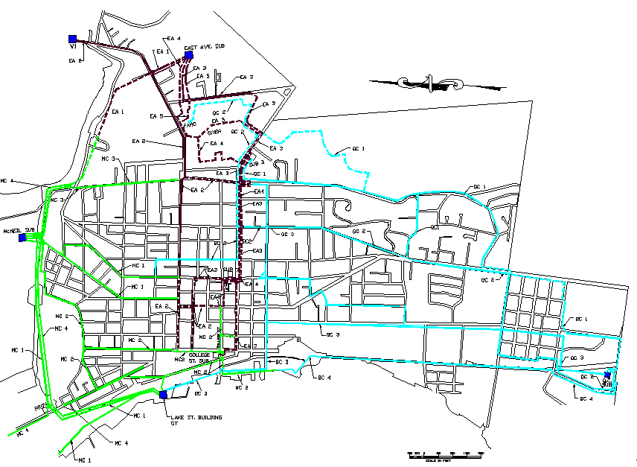43,500 (approx.)

* Established in 1905, the Burlington Electric Department serves approximately 16 square miles, including the Burlington Airport.
* Customer count - 20,761

Residential: 16, 876

Commercial: 3,885

* Commercial accounts consume nearly 75 percent of total energy load.

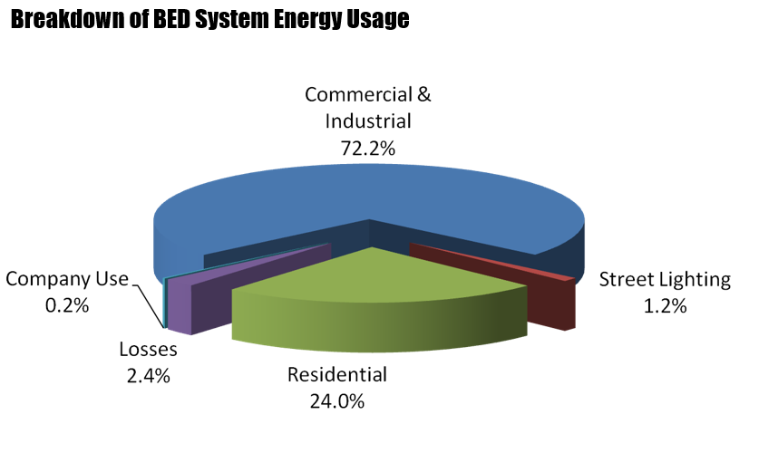

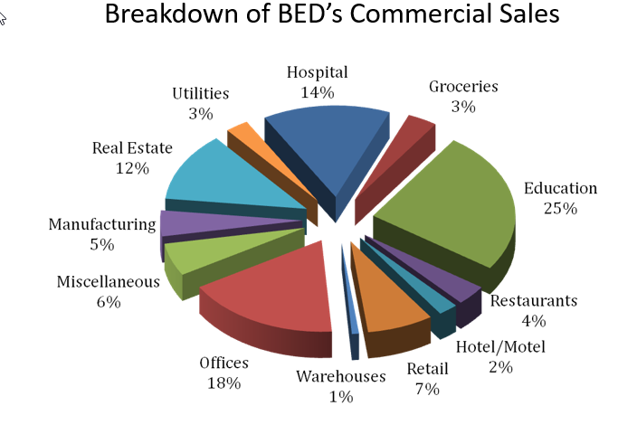

* Top 20 commercial accounts consume nearly 50 percent of the total energy load delivered (approx. 350 GWh annually).
* Energy Efficiency has essentially helped to flatten BED’s energy load requirement since the 1990’s.
* Approximately 11,000 residential customers consume less than 500 kWh per month; 390 kWh is the class average.
* 60 percent of residential, and 70 percent of commercial, customers rent or lease.
* 95 percent of residential, and 99 percent of commercial, buildings are served by natural gas.
* Vermont Gas Systems (an investor-owned natural gas utility) is also an appointed Energy Efficiency Utility and offers a suite of residential and commercial programs.
* BED turns over about 35 percent of its residential customers annually.
* BED’s long-term energy efficiency efforts along with increasing appliance standards, and the high saturation of both natural gas and rental apartments, help to shape residential electric usage:

**2016 Electric Utility Comparison**

Average Annual kWh Use per Residential Customer

|  |  |  |  |
| --- | --- | --- | --- |
| COMPANY |  | AVG USE | RANK |
| BARTON | MUNI | 5,206 | 3 |
| **BURLINGTON** | **MUNI** | **4,853** | **1** |
| ENOSBURG | MUNI | 8,843 | 17 |
| GMP | PRIV | 6,772 | 13 |
| HARDWICK | MUNI | 5,787 | 5 |
| HYDE PARK | MUNI | 6,823 | 14 |
| JACKSONVILLE | MUNI | 5,450 | 4 |
| JOHNSON | MUNI | 6,483 | 11 |
| LUDLOW | MUNI | 5,198 | 2 |
| LYNDONVILLE | MUNI | 6,392 | 10 |
| MORRISVILLE | MUNI | 6,033 | 7 |
| NORTHFIELD | MUNI | 6,256 | 8 |
| ORLEANS | MUNI | 6,719 | 12 |
| STOWE | MUNI | 6,885 | 15 |
| SWANTON | MUNI | 8,033 | 16 |
| VEC | COOP | 6,315 | 9 |
| WEC | COOP | 5,889 | 6 |
| VERMONT AVG |  | 6,556 |  |

APPENDIX B

Burlington’s Climate Action Plan 2010, available at:

<https://www.burlingtonvt.gov/sites/default/files/CEDO/Sustainability/Climate%20Action%20Plan.pdf>

Burlington’s Most Recent Published Emissions Data, available at:

<https://www.burlingtonvt.gov/sites/default/files/u268/City%20of%20Burlington%20Emission%20Summary%20and%20Trends.pdf>

APPENDIX C

**BED Strategic Direction** 

APPENDIX D

Vermont Total Energy Study, available at: <http://publicservice.vermont.gov/publications-resources/publications/total_energy_study>

APPENDIX E

planBTV, available at: https://www.burlingtonvt.gov/planBTV

Appendix F

BED Integrated Resource Plan: <https://www.burlingtonelectric.com/irp>

BED Triennial Plan: <https://burlingtonelectric.com/sites/default/files/inline-files/BED-EEU-2018-2020-Triennial-Plan.pdf>

BED 2018 Tier 3 Plan: <https://burlingtonelectric.com/sites/default/files/inline-files/BED-2018-Tier-III-Plan.pdf>

BED 2017 Energy Efficiency Annual Report: <https://www.burlingtonelectric.com/sites/default/files/inline-files/2017%20BED%20DSM%20Annual%20Report.pdf>